**Filtering and Routing**

**Configuring inputs (inputs.conf)**

1. Go to $SPLUNK_HOME
2. Then go to /$SPLUNK_HOME/etc/apps/search
3. Create new directory

# mkdir local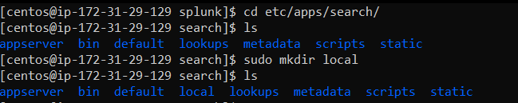

1. Create a new inputs.conf in local directory

# vim inputs.conf

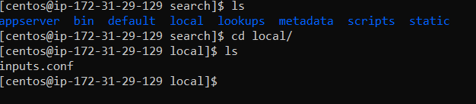

1. Write this configuration in inputs.conf

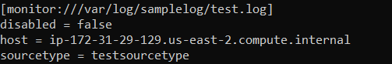

**Configuring props.conf**

1. Go to $SPLUNK_HOME
2. Then go to $SPLUNK_HOME/etc/system/local/
3. Create new props.conf

**[testsourcetype]**

**TRANSFORMS-routing = ErrorChecking, SuccessChecking**

**Configuring transforms.conf**

1. Go to $SPLUNK_HOME
2. Then go to $SPLUNK_HOME/etc/system/local/
3. Create new transforms.conf

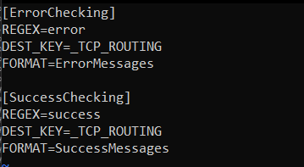

**Creating outputs (outputs.conf)**

1. Go to $SPLUNK_HOME
2. Then go to $SPLUNK_HOME/etc/system/local/
3. Remove outputs.conf

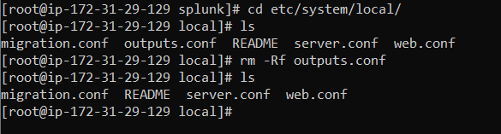

1. Create a new outputs.conf

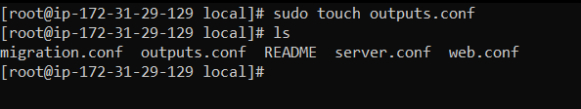

1. Edit outputs.conf

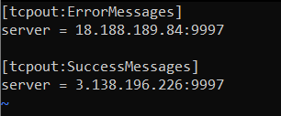

****** NOTE****

1. Restart Splunk after finishing all configurations

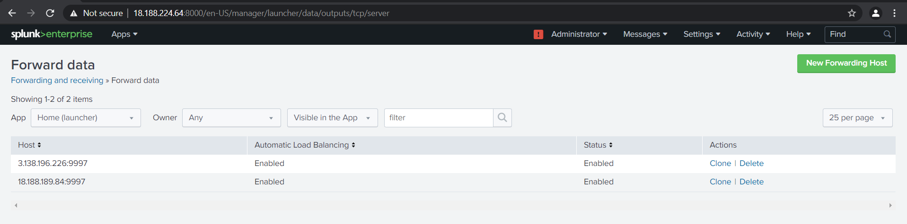

**Result of Filtering and Routing**

**Error events (index1)**

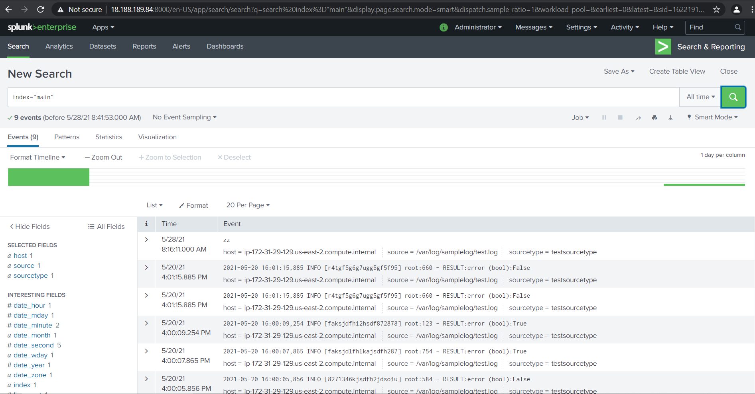



**Success Events (Index2)**

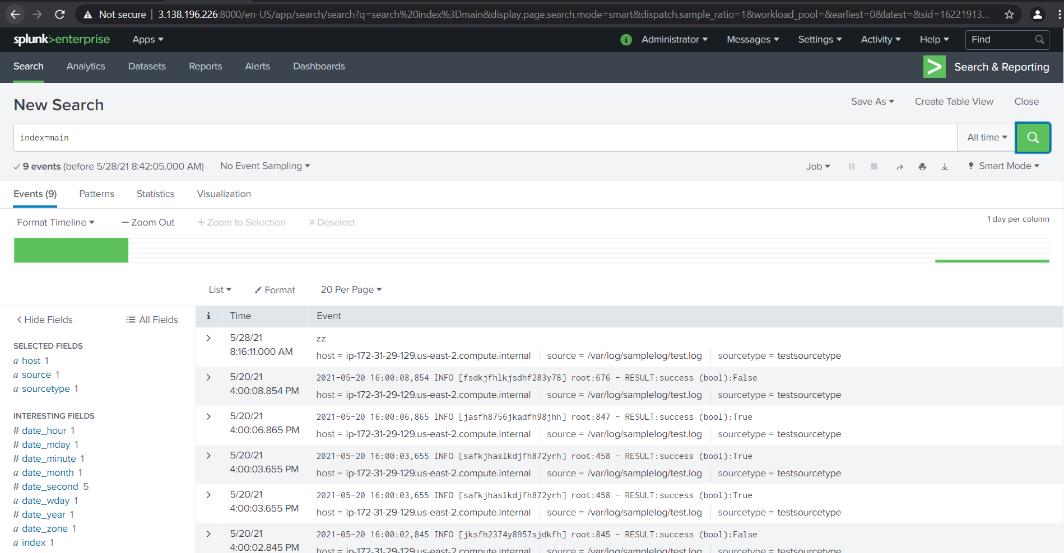



**Masking**

**Configuring inputs (inputs.conf)**

1. Go to $SPLUNK_HOME
2. Then go to $SPLUNK_HOME/etc/system/local/
3. Create a new inputs.conf file

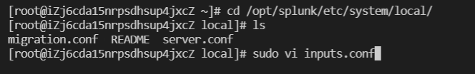

1. Put this into inputs.conf

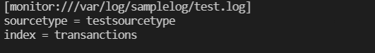

**Configuring props (props.conf)**

1. Go to $SPLUNK_HOME
2. Then go to $SPLUNK_HOME/etc/system/local/
3. Create a new props.conf

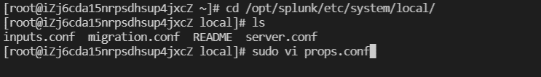

1. Put this into props.conf file



**\*\*\*\*\*\*\*\*\*Note**\*\*\*\*\*\*\*

**Restart splunk after configuring inputs.conf and props.conf**

**Result:**

**Before masking**

**Sample data:**

2021-03-26 12.00.00 cardno:1234-5678-9874-5869 action:credit status:success

2021-03-26 12.00.00 cardno:9854-8954-8255-5854 action:credit status:success

**After masking**

